Identity Governance

Standard Operating Procedures

Tasks monitoring and activities to be performed after task not triggering in SP

**Document Details**

|  |  |
| --- | --- |
| Project Name | BestBuy IDAM |
| Account | BestBuy |
| Current Version | 0.01 |
| List of Contributors | Atharva Wankhede |
| Customer Contact Information |  |

Document Control

|  |  |  |  |
| --- | --- | --- | --- |
| **Version** | **Date** | **Amended By** | **Comments** |
| 0.01 | 09/26/2024 | Atharva | Draft Version |
|  |  |  |  |

**Tasks which need to be Monitor daily:  
1)** **Workday Delta Aggregation  
2)** **Refresh Identity Cube Task for Synchronize Attributes  
3)** **Refresh Identity Cube for Role Assignments  
  
How to check the Status:  
Step 1:  
A)Login to SailPoint prod environment with -a credentials(**[**https://identity-ent.us.bestbuy.com/identityiq/home**](https://identity-ent.us.bestbuy.com/identityiq/home)**)**

**B) Navigate to Setup>>Tasks tab in Tasks tab navigate to tasks results and search for all three tasks and see last time of completion**

**as we can see above task got Started: 9/26/24, 4:30:01 PM and Completed: 9/26/24, 4:42:10 PM and Status: Success**

**C) So, this task results we check for all schedule tasks which is mentioned above.**

**d) If the scheduled tasks got stuck for long time or task got failed or in tasks users list not getting fetched or task showing in pending state for long while in that case if task is in running mode, we must terminate the task from task result by right click on the running that terminate task option will pop up we can click on terminate task.**

**For Example: Refresh Identity Cube Task for Synchronize Attributes  
  
**

**after refreshing the page that task will get cancelled. If still task is in running state, we must terminate from Debug page.  
Go to Debug page >> Select Object = Task Results >>and in filter by name = put running task name**

**then select that task and delete it as shown in below.**

**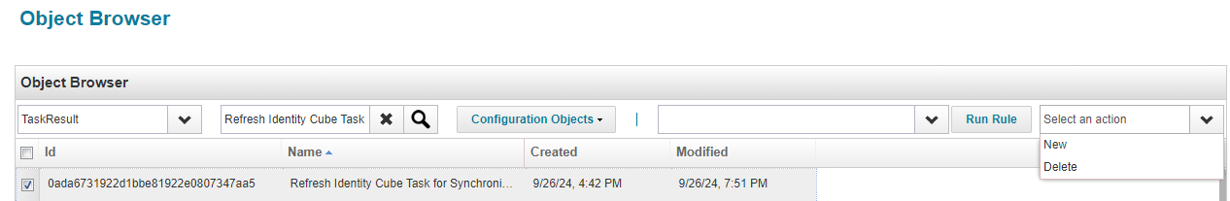  
  
  
e) After termination of task we have to check the next scheduled time for terminated task in this example we will see the next scheduled time for task from Admin Console >>Scheduled Tasks>> to check next schedule time.**

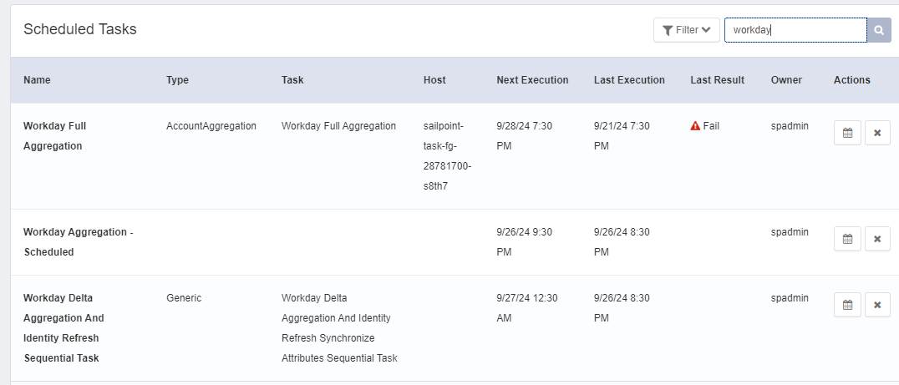

**F) At last wait for next schedule time if task not getting triggered and appropriate time then we have to run restart of SailPoint pods.  
  
g) Steps for restart of Pods:  
Login to SailPoint Prod using below cmd in command prompt.**

**kubectl config use-context eks-t0-east**

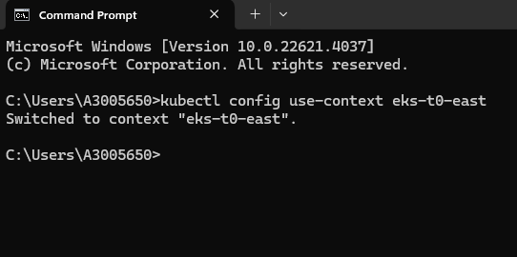

**Note:**

**kubectl config use-context eks-t0-east (Prod)**

**kubectl config use-context eks-t0-stage (Stage)**

**kubectl config use-context eks-t0-test (Test)**

# **To get list of Task and UI Pods:**

**kubectl get pods**

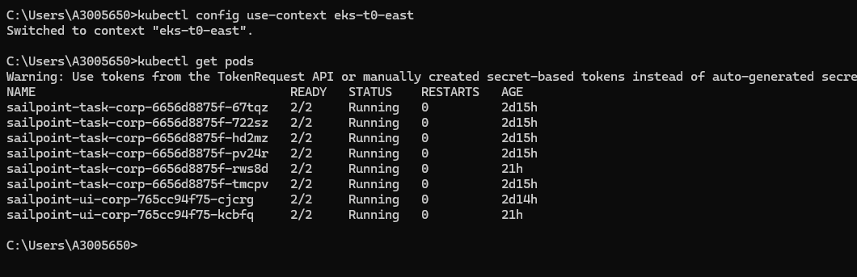

**You will see 6 Task pods and 2 UI pods from the above screenshot.**

# **To restart and Task and UI pods**

**Restarting pods will result in deleting old pods and creating new pods.**

### **To restart Task pods:**

**kubectl rollout restart deployment sailpoint-task-corp**

**It will take 5-10 mins to restart.**



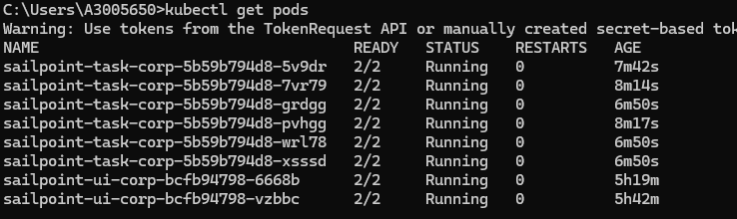

### **To restart UI pods:**

**kubectl rollout restart deployment sailpoint-ui-corp**

**It will take 1-2 mins to restart.**



**Note:**

**In production, you should not restart Task and UI pods at the same time.**

* **Long running Fargate Instance**

**It has been seen that tasks are also getting hung when they start running in fargate instance. Run the below steps to delete the fargate instance before terminating the task**

1. **kubectl config set-context --current --namespace=identity-ent-batch**
2. **kubectl get jobs**
3. **kubectl delete job <job_name> eg kubectl delete job sailpoint-task-fg-28610340**
4. **kubectl config set-context --current --namespace=sailpoint-corp**